STAFF: ____________ B/L PROVIDED: Y N B/L #___________________
DATE: ____/____/____ SI#: ____________________ DD______/______/________
D M Y D M Y

1290 FEWSTER DRIVE, MISSISSAUGA, ON L4W 1A4
TEL: (905) 602-9622 FAX: (905) 602-8262
WEBSITE: WWW.MCCALLS.CA EMAIL: ORDERING@MCCALLS.CA

BUSINESS ACCOUNT APPLICATION FORM
McCall’s Bakers Warehouse is a wholesale cash and carry warehouse for trade customers. Please complete and return this form with your business license. The completed form can be faxed or emailed to the above. Please allow 2 business days to process. We accept Debit, Visa, MasterCard and PayPal.

PLEASE PRINT CLEARLY

A COPY OF A VALID BUSINESS LICENSE MUST BE INCLUDED WITH APPLICATION.

Corporate Number:

Operating Name:

Address: City:

Prov: Postal Code: Phone: ( ) Fax: ( )

Signing Officer/Owner’s Name: Email:

Contact Name (if different from above): Email:

Type of Business: Reseller Distributor End User Retail Number of Years in business?

To access business level pricing online, a valid email address must be provided:

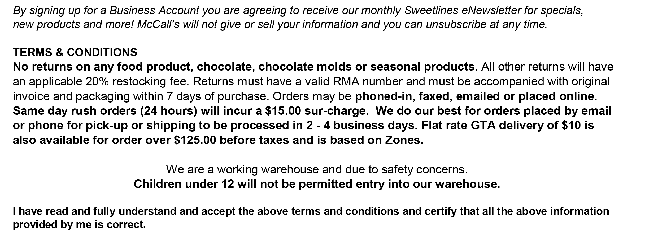
Main Email Address for account set-up:

Signed: Date:

